***Virginia Junior Classical League***

*presents this*

Certificate of Excellence

*to*

Matt DeLancey

*of*

Osbourn Park High School

*for*

*9th Place in English Oratory*

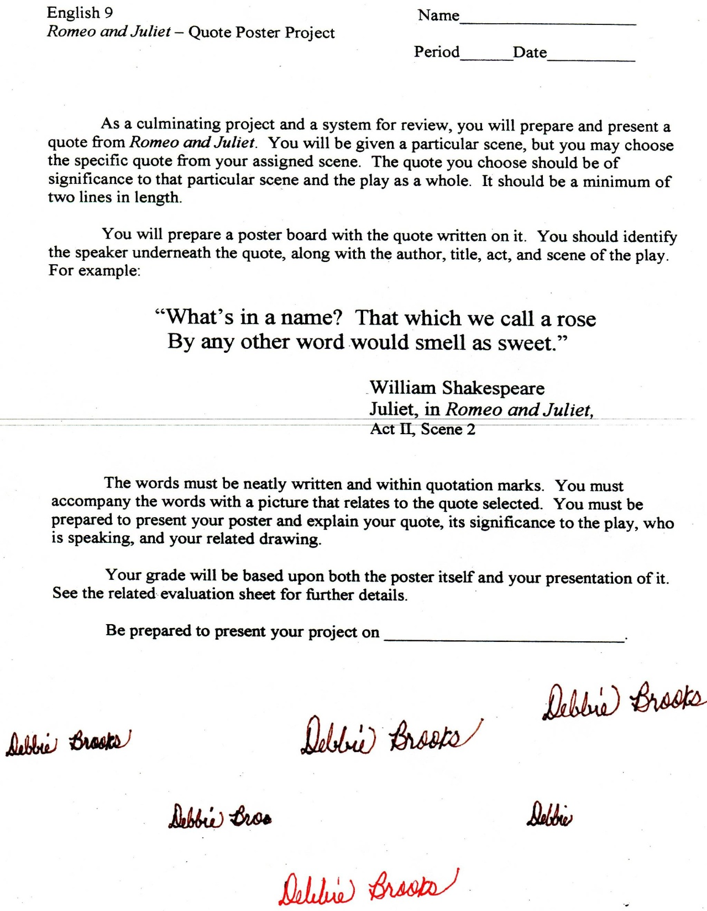

Microsoft Office Signature Line...

*a.d. viii Kal. Dec. MMDCCLXVII A.U.C. 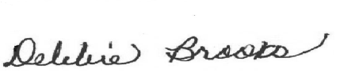*

***Virginia Junior Classical League***

*presents this*

Certificate of Excellence

*to*

Matt DeLancey

*of*

Osbourn Park High School

*for*

*10th Place in Mythology*

**

Microsoft Office Signature Line...

*a.d. viii Kal. Dec. MMDCCLXVII A.U.C. *